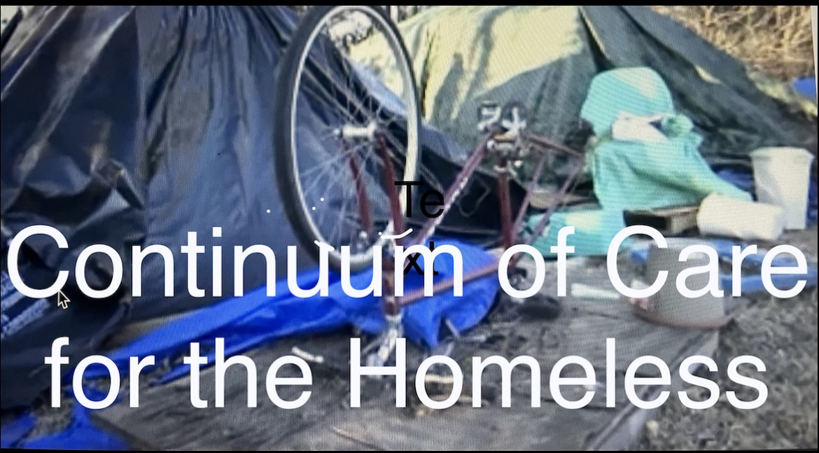

**In Huntsville**

**Progressive Union Missionary Baptist Church**

1919 Brandontown Rd. 256-539-1070

**St. Stephen’s Episcopal Church**

8020 Whitesburg Dr. 256-881-7223

**Latham United Methodist Church**

109 Weatherly Rd. 256-881-4069

**Church of the Nativity, Episcopal**

208 Eustis Ave. 256-533-2455

**Monte Sano United Methodist Church**

601 Monte Sano Blvd. 256-533-6083

**First Christian Church**

3209 Whitesburg Dr. 256-881-0150

**St. Thomas Episcopal Church**

12200 Bailey Cove Rd. 256-880-0247

**The Rock Family Worship Center**

3401 Holmes Ave. NW 256-533-9292

**Manna House**

2110 S. Memorial Pkwy. 256-503-4848

(Monday, Wednesdays & Thursday 4-7pm)

**First Stop, Inc. @ The Living Room**

2820 Governors Dr. SW (not **SE**)

Weekdays 8am - 1pm 256-533-3391

**North Alabama Coalition for the Homeless**

1580 Sparkman Dr. NW Ste.111 256-261-3029

Mon.- Thur. 8am – 4:30pm & Fri. 8am - 11:30am

**The Salvation Army Emergency Shelter**

305 Seminole Dr. SW 256-536-5576

Weekdays 8am - 4pm

**Thrive Alabama**

301 Governors Dr. Ste. 160 (inside UAB Bldg.)

Mon.-Thru. 8am - 5pm & Fri. 8am - noon

256-536-4700 ex. 2209

**Alabama Non-Violent Offenders (ANVOO)**

701 Andrew Jackson Way NE (United Way Bldg.)

Weekdays 9am - 4pm 256-288-3175

**Rose of Sharon Soup Kitchen**

723 Arcadia Circle, NW 256.532-2970

Tues.-Thurs. 9am – 1pm

**In Madison**

**St. Matthew’s Episcopal Church**

786 Hughes Rd. 256-864-0788

(please use bin in the breezeway)

# **ANNUAL BLANKET & COLD WEATHER GEAR DRIVE**

# **October – February**

# **Collection for the Homeless:**

# *Gently Used or New - Adult sizes, only, please*

# **Blankets Sleeping Bags**

# **Coats/Jackets Toboggans**

# **Gloves/Socks Sweat Shirts/Pants**

# **Thermal Underwear Warm Scarves**

# **Donations may be dropped off at these locations**

# ***Please call to confirm office hours before dropping off donations***

# 

# 